Software Requirements:
- Specify the business functions in different “situations”.
Ex: how the system will manage and protect user’s data.
- User requirements often high-level, vague, and incomplete

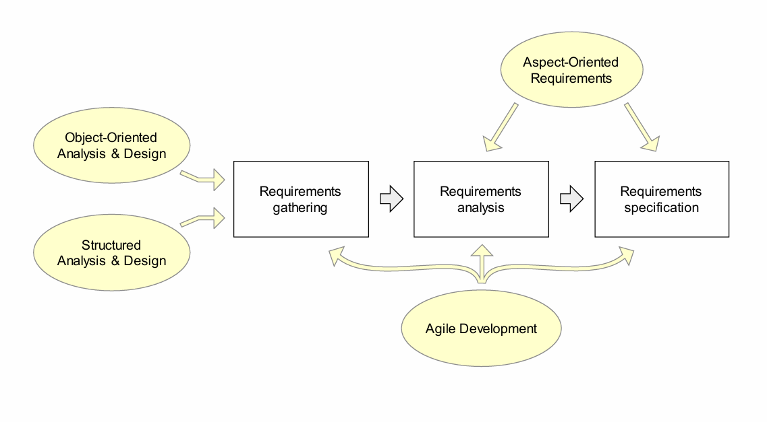
Requirement gathering:
- Help customers to define the requirements, how it fit into the need of business
- Meeting with stakeholders, gathering information about the system
Requirement analysis:
- Refining and modifying
- Determine scenarios, risk analysis
Requirement specification:
- Documenting the system requirements, consistency
- Write use-case, SRS, user stories

Requirement Derivation:
- Detecting that a problem exists is different from defining the problem.
- Requirements Derivation là quá trình biến “mong muốn” thành “yêu cầu thực tế và khả thi”.
- Ex: “Tôi muốn hệ thống giống Amazon.”
Requirement thật phải xét:
- Có đủ ngân sách không?
- Có đủ đội dev không?
- Có cần bảo mật cao không?
- Luật dữ liệu có cho phép không?

Requirement as User Stories:
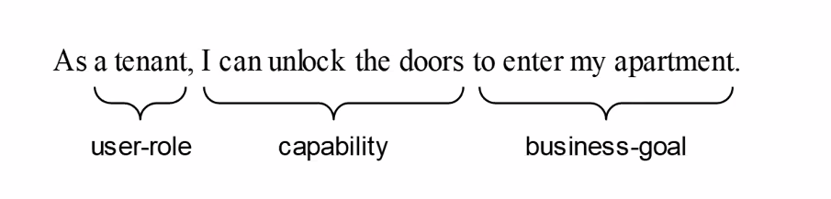
- Write by the customer or user, not dev
- Preferred tool in Agile method (not too specific at the beginning)
- Acceptance tests are written when the story is identified
Ex: As a tenant, I can unlock the door
Acceptance test:
. Door open when the PIN is correct
. Unlock takes 2sec
Acceptance test:
- Assessing the project success criteria
- Conduct/Feedback by the customer throughout the project
- Give specific input value to see if the system passes or fails
- Can’t test 100% all scenarios but systematic approach can increase the expected degree of coverage
Systematic approach:
- làm việc theo phương pháp có cấu trúc thay vì cảm tính
Prototyping:
- tạo ra những phiên bản thử nghiệm, mockup UI, mockup function
- Minh họa ý tưởng, làm rõ yêu cầu, nhận feedback sớm

Requirement Analysis:
- Requirement thường viết chung chung thì bước này làm rõ
- Example: Intruders will not be able to succeed with a dictionary attack.
How do we know whether it is the user type 3 times incorrectly or the hacker is dictionary attack
- We need Buiness Policy! (parameter determined: type only 3 times incorrect or block the account in 15 mins)
Business Policy:
- Explicit identification of BP always allows involving other stakeholders, particularly customers in decision making about the BP solution.
(luôn để business quyết định)
- After eliciting/gathering requirements, those requirements are unstructured
- Categorizing or clustering requirements (IF, BF, DF, UI, IS, FC)
- Prioritizing the requirements

Analyst’s Task:
- This includes 3 different descriptions :
+ the requirement (what user wants)
+ the problem domain (how the world works)
+ the specification (what software need to do)

- These are 3 different things, so analysts need to identify and understand what user wants and how the world works to link them together to write the SRS
Ex:
the requirement:
- User wants to unlock the door and it will open the door after a second
The problem domain:
- High voltage => unlock
- Low voltage => lock
The specification:
- If the entered PIN number is correct, put High voltage the output
- Start timer
- Timers expires then put Low voltage

Decomposition of Business Goal
- Make the unclear requirements to be more detailed
Ex: Increase online sales
- Improve checkout, improve search, add promotions, …

- There are 2 ways:
+ Breadth-first refinement
You define the main areas first before going deep into any one of them
Online Learning Platform
/ | | | \
Registration Course Payment Video Certificate

+ Dept-first refinement
Choose one branch then going deep into it before touching any other branch

